Module List:

Claims Registration Screen 2

Claim Recovery 3

# Claims Registration Screen

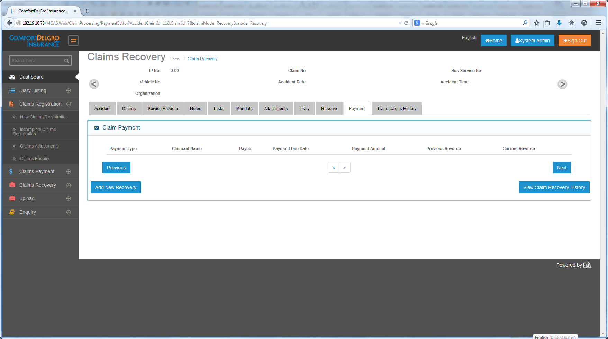

14-11-2014:

New Claims Registration

1. New Claims Registration – This Menu will be used for Claims Entries Creation for all Organization Category (e.g. Public Bus, Train, Taxi, Rental Vehicle, Private Bus, Private Bus).
2. Users under Public Bus and Train will use the Screen Layouts as per Claim registration presentation ( PPT file created by India Ebix Team ) for Claims Creation
3. Users under Private Car, Private Bus, Rental Vehicle and Commercial Vehicle will use the screen layouts as per Car Draft PDF file.
4. Users under Taxi will use another screen layouts (which is not provided as per this update)

*[India Ebix comments 17 Nov 2014]*

*Please Confirm below table to follow for screen creation:*

|  |  |  |
| --- | --- | --- |
| *S.No* | *Organization Category* | *Reference Document for Tab screen layout* |
| *1* | *Bus* | *Claim registration screens V5* |
| *2* | *Train* | *Claim registration screens V5* |
| *3* | *Private Car* | *Pte Car Draft Sample Screens 11-11-14* |
| *4* | *Private Bus* | *Pte Car Draft Sample Screens 11-11-14* |
| *5* | *Rental Vehicle* | *Pte Car Draft Sample Screens 11-11-14* |
| *6* | *Commercial Vehicle* | *Pte Car Draft Sample Screens 11-11-14* |
| *7* | *Taxi* | *Pending* |

1. If user is under one single Organization Type, clicking on the Claims Registration will bring user to its screen layout related to its Organization Type (e.g. User is under SBST which is under Public Bus so the screen will go to the Public Bus Screen Layouts)
2. If user is under multiple Organization Types, System will show a screen with a Dropdown and ask user which Organization to create the Claim. (e.g. if User is under SBST (Public Bus) and Comfort Delgro Buses (Private Bus) and when user selects Comfort Delgro Buses, the layout will change to those under Private Bus.

*[India Ebix comments 17 Nov 2014]*

*Please provide screen layout details on which user will choose organization category.*

Incomplete Claims Registration

1. All File uploads (TAC and SAP) will go to this Incomplete Claims Registration Menu.
2. We do not have any information for SAP File uploads as yet.
3. Any Saved Entries from New Claims Registration will go to the Incomplete Claims Registration.

# Claim Recovery

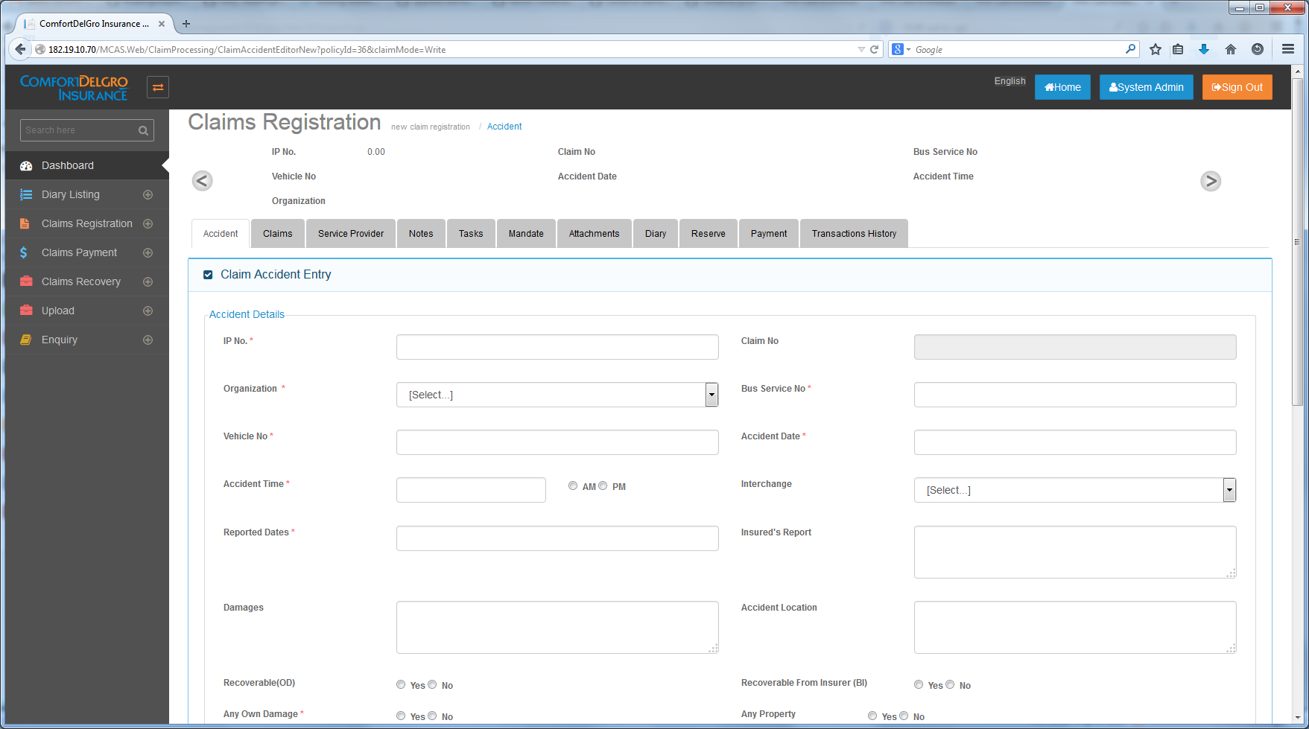

14-11-2014 (Transferred from Claims Recovery Doubts V1.docx) :

Claim Registration Screen

1. To Add A New Recovery Tab to the Claims Registration Screen.
2. Purpose: When user selects Recoverable (OD) = Yes and/or Recoverable from Insurer (BI) = Yes, all the Claim Entries will be populated to this Recovery Tab for overall view. User can click on the individual claim entries and it will bring user to the Claim Recovery UI at the Claim Recovery Menu to process the Recovery.
3. Suggested Grid Layout:

|  |  |  |  |  |  |  |
| --- | --- | --- | --- | --- | --- | --- |
| +/- | Claim Type | Claim No. | Claimant Name | Status | Action |  |
| + | OD |  |  | << Empty when none; Processed when Recovery is done>> | << Select >> |  |
|  |  |  |  |  |  |  |
| + | BI |  |  | << Empty when none; Processed when Recovery is done>> | << Select is only available for Status is empty >> |  |

*[India Ebix comments 17 Nov 2014]*

1. Please provide flow of screens information.
2. For an example first screen will be search recovery screen which will come when user will click on recovery tab.
3. *Then what will be second screen and further sequence.*

03-12-2014:

Screen Flow:

Clicking any of the Claim Entries is (in the Recovery Tab) will bring the user to the Claims Recovery Processing Screen to start the processing.

Difference between Recovery Tab and Claims Recovery Processing is that Recovery Processing comes with Search Functionalities to search for all Claims created. Recovery Tab is for that particular claim only.

*When Recoverable (OD) is Yes – all OD Claim with Approved Payment will flow to the Recovery Tab (Need to confirm with CDGI again).*

When Recoverable from Insurer (BI) is Yes – all BI with Approved Payment Claims will flow to the Recovery Tab

The Results will be displayed in the Suggested Grid Layout as per Item #3. There’s no need for any search functionality.

Status is initially empty. Status is changed to Processed when Claims Recovery is completed.

When Claims Recovery is done, the Status will change to Processed.

Special Requirements :

Recovery for BI is to be done in a batch and for the first batch, the deductible (defaulted as $15,000) will be taken into account. Note that if the first batch is less than 15,000, user cannot go for BI Claims Recovery. If the first batch is processed, the deductible is no longer taken into account for the second batch.

How to define First Batch and Ongoing Batches – The first and ongoing Payment Entries (e.g. 1 – 5) made for BI Claims will be populated here. Once the user clicks on Select Link, the set of (1 – 5) BI Claims will be processed. The set of (6 – N) will be considered as Second Batch when the Select Link is clicked.

*[Varun comments 17 Nov 2014]*

1. We need to know business flow of whole process.
2. Why we are using batches for recovery?
3. How we are managing deductibles in software?
4. Screen flow of managing batches of bi recoverable.

03-12-2014:

Business Flow:

* Recovery for BI is only for Payments that have been made and User wants to recover
* Recovery for BI is done in batches because of the initial Deductible value (if the sum of the first batch of BI Payment is lesser than the Deductible Value, system will prevent user from creating BI Claims Recovery)
* When the first batch is more than deductible, the difference between the two is the amount that can be recovered.
* When there is second or more batches of BI Claim Payments, the initial Deductible Value will not be applied and User can recover the full amount.

Screen For Deductible

We need to have a new screen tab entitled Deductible and a new Master Table.

When There Is No Deductible Value:

Initial Screen:

|  |  |
| --- | --- |
| Organization Category * | << Drop Down >> |
| Organization Name * | << Drop Down – Display according to Category Selection >> |
| Deductible Amount * | << Text Field >> |
| Effective From * | << Date Field >> |
| Effective To | << Date To >> |
| * is mandatory |  |

Display Result:

|  |  |  |  |  |  |
| --- | --- | --- | --- | --- | --- |
| Org Category | Org Name | Deductible Amount | Effective From | Effective To | Action |
| Bus | SBST | $15,000 (Always display the latest one) | 01/01/2014 |  | << Edit >> | << History >> |
|  |  |  |  |  |  |

When User Needs To Change Deductible Amount

To change the Deductible Amount, user needs enter the Effective To Date to expire the current one. So when Effective To Date is entered:

|  |  |
| --- | --- |
| Organization Category | Bus (Read Only) |
| Organization Name | SBST (Read Only) |
| Deductible Amount | $15,000 (Read Only) |
| Effective From | 01/01/2014 (Read Only) |
| Effective To | << Date Field To Be Entered>> |
| *// So When Date Field is entered… e.g. 30/11/2014… the below fields are opened up* | |
| New Deductible Amount | << Text Field >> |
| Effective From | Default to << Effective to Date + 1 >> |
| Effective To | << Text Field >> |

Screen Flow:

When summation of first payment batch is less than Deductible, System will prompt to user that it cannot be processed

In Recovery Tab / Claims Recovery Processing:

When user clicks on the first batch of BI Payment Claims, system will redirect to BI Recovery Screen and Deductible belonging to the Organization Name will populate from Master Table

When Recoverable from Insurer (BI) is Yes. System will start tracking Payments made for all BI Claims and display them in the Recovery Tab & Claims Recovery Processing

Deductible will no longer be applied and user can process the recovery straight away and status is changed to Processed.

In Recovery Tab / Claims Recovery Processing:

When user clicks on the second batch of BI Payment Claims, system will redirect to BI Recovery Screen

When summation of first payment batch is more than Deductible, System will process and Status is changed to Processed.

Claims Recovery Screen

When User clicks on Select Link under OD in the Recovery Tab or after searching:

Suggested Claim Recovery Screen For OD:

|  |  |
| --- | --- |
| **Field Name** | **Field Type** |
| Recover From | << Text Field >> |
| Address1 | << Text Field >> |
| Address2 | << Text Field >> |
| Address3 | << Text Field >> |
| Postal Code | << Text Field >> |
| Recovery Reason | << Text Field >> |

|  |  |  |
| --- | --- | --- |
|  | Recoverable Amount | Approved Mandate |
| << Listing to follow Payment Screen for OD >> | << Text Field >> | << Read Only – To Populate values from Mandate Entry that is approved for this particular OD >> |
|  |  |  |
|  |  |  |
|  |  |  |
| Total | << Total Amount from above inputs >> |  |
|  | << Submit Button >> |  |

Validation:

1. Recoverable Amount must be greater or equal to Approved Mandate Amount
2. When the Submit Button is clicked, the Total Amount will be deducted from Outstanding Reserve and Mandate Amount relevant to this OD Claim

Claims Recovery Screen

Search Fields Required:

* Claim No.
* Claimant Name
* Recoverable Type << Dropdown – Own Damage (OD) / Bodily Injury (TPBI) >>

When User clicks on Select Link under BI:

|  |  |  |
| --- | --- | --- |
| **Field Name** | **Field Type** | **Remarks** |
| Total TPBI Payout | << Text Field >> | This is pulled from the total values of TPBI Claims Payment |
| Deductible / Excess Limits (currently set as 15,000) | << Text Field >> | This value is pulled from CDGI’s Deductible value from own panel of Insurer or Insurance Policy (from System Admin) |
| Amount To Recover | << Text Field >> | Value = Total TPBI Payout - Deductible |
| Reason | << Text Field >> | Default to “Deductible Exceeded” |

Validation:

* For the first set of BI Recovery, Deductible (currently default as 15,000) is taken into account
* If Total TPBI Claims Payment is less than Deductible, Recovery cannot be processed. System to prompt user that this batch cannot be processed because Total TPBI Claims Payment is less than Deductible.
* If Total TPBI Payment is more than Deductible in the first batch, Recovery can be processed.
* This Entry is saved and the first batch is marked with a new status of processed and will not be allowed to use for ongoing batches.
* Deductible will not be taken into account for ongoing batches (which means any future recoveries can be processed).

*[India Ebix comments 17 Nov 2014]*

* *Please organize a meeting to discuss overall process of recovery and screen flow.*
* *Our understanding of linkage among Recovery, Reserve, Mandate and payment.*

1. *At the time of Claim registration , user will enter Reserve*
2. *Based on Reserve user can only give Mandate approval*
3. *Based on Mandate approval user can only make payment*
4. *Based on Payment amount user can only make recovery from user.*

***[India Ebix Suggestion]***

1. *It is better to have a pictorial representation rather textual representation of business flow and screens details of a module.*
2. *Please try to create screen so that our understanding can be in synch with business.*

***Please provide feedback.***

03-12-2014

Screen Flow

|  |  |  |  |
| --- | --- | --- | --- |
| Stage 1 | Stage 2 | Stage 3 | Stage 4 |
| Initial Reserve to be created | Mandate to be created and to be approved by Supervisor | Payment to be made only when Mandate is approved.  Recovery for OD can be made at this time.  Payment Request has to be approved by Supervisor. | Recovery for BI can only be made after Payment for BI Claims has been approved. |
|  |  |  |  |